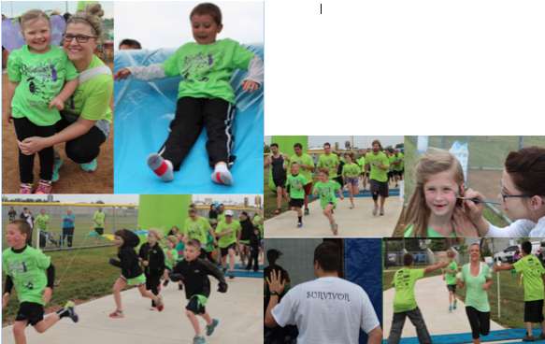

* REGISTER AT: WWW.BELLAFLIES.ORG

**RACE TIME: *5K* 6:30PM *ONE-MILE* 7:20PM**

**DAY OF REGISTRATION: 5:00-6:20PM**

**COURSE: PROFESSIONALLY TIMED *FLAT* OUT AND BACK**

**FRIDAY, MAY 8TH 5:00-8:30PM**

***ALL PROCEEDS WILL BE DONATED TO PEDIATRIC STROKE RERESEARCH***

Strides for Strokes 2015

## **FAMILY FRIENDLY EVENT**

## **Professionally Timed 5k, One-mile Fun Run, Face Painting, Bounce House, Obstacle Course, 30+ Item Auction, Massage Station, Food, Drink, Music, and MORE!!!**

Rogers Regional Sports Park Field #6 2150 N Dixieland Rd, Rogers, AR 72756